PLASTICITY MODELLING USING DRUCKER–PRAGER CRITERION
UNDER PLANE STRESS CONDITION USING UMAT IN ABAQUS



Submitted By : Rajkumar Singh
Submitted to : Dr. Mayank Chauksy
Department : Mechanical Engineering
Course : ME666
Year : 2026

ABSTRACT
The present report focuses on the detailed constitutive modelling of the Drucker–Prager plasticity model under plane stress condition using UMAT implementation in Abaqus. The objective of this work is to understand the theory of computational plasticity, derive the governing constitutive equations, develop a predictor–corrector integration algorithm, implement the constitutive model using FORTRAN coding in UMAT, and validate the developed model using the Abaqus built-in Drucker–Prager formulation.
Plasticity modelling plays an important role in nonlinear finite element analysis because many engineering materials exhibit permanent deformation after yielding. Materials such as concrete, rock, soil, polymers, and geomaterials show pressure-dependent yielding behaviour which cannot be represented accurately using classical elastic constitutive equations. The Drucker–Prager model is therefore selected because it provides a smooth pressure-sensitive yield surface and better numerical convergence.
The report includes detailed derivation of stress invariants, constitutive relations, return mapping algorithm, Newton–Raphson iteration, stress correction procedure, and tangent stiffness formulation. Special emphasis is given to the elastic predictor and plastic corrector algorithm used in computational plasticity. Each iteration involved in strain increment update and stress correction is explained systematically. The developed UMAT is finally compared with the Abaqus built-in Drucker–Prager model to validate the numerical implementation.

REPORT WORKFLOW
The complete workflow of the present study is organized systematically so that the development of the Drucker–Prager constitutive model can be understood step by step. The workflow begins with the study of elasticity and plasticity theory, followed by derivation of stress invariants and constitutive equations. After understanding the theoretical framework, the elastic predictor and plastic corrector algorithm is developed. The return mapping algorithm and Newton–Raphson iteration scheme are then implemented for stress integration. Finally, the constitutive equations are coded using FORTRAN in UMAT and validated using Abaqus.
- Study the theory of elasticity and plasticity
- Understand pressure-dependent yielding behaviour
- Derive stress invariant equations
- Formulate Drucker–Prager yield criterion
- Develop elastic constitutive matrix for plane stress condition
- Develop elastic predictor and plastic corrector integration algorithm
- Implement return mapping algorithm
- Develop Newton–Raphson iteration procedure
- Implement constitutive equations in UMAT using FORTRAN
- Compile and link UMAT with Abaqus
- Create finite element model under plane stress condition
- Perform simulations using Abaqus built-in Drucker–Prager model
- Compare UMAT and built-in model results
- Validate convergence and stress integration behaviour

CHAPTER 1 – INTRODUCTION

1.1 Introduction to Plasticity
Plasticity is the branch of solid mechanics that deals with permanent deformation of materials subjected to external loading. When engineering materials are loaded within the elastic limit, the deformation disappears after unloading. However, when the applied stress exceeds the yield stress, the material experiences irreversible deformation known as plastic deformation.
The study of plasticity is extremely important in modern engineering because many practical components operate under high stress conditions. Structural members, automotive components, pressure vessels, metal forming applications, and geotechnical structures all experience nonlinear material behaviour during service conditions. Therefore, accurate constitutive models are required to predict yielding and permanent deformation.

1.2 Importance of Plasticity Modelling
Plasticity modelling is an essential part of nonlinear finite element analysis because real engineering materials rarely remain purely elastic under practical loading conditions. Elastic models are insufficient for predicting permanent deformation and material failure. Advanced constitutive models help engineers understand material response under complex loading paths.
Computational plasticity also plays an important role in numerical simulation because it improves prediction accuracy and helps reduce experimental cost. The development of robust constitutive integration algorithms is therefore a major area of research in computational mechanics.

1.3 Drucker–Prager Yield Criterion
The Drucker–Prager criterion is a pressure-dependent yield model widely used for materials such as soil, rock, concrete, powders, and polymers. Unlike the von Mises criterion, which depends only on deviatoric stress, the Drucker–Prager criterion considers the influence of hydrostatic pressure on yielding.
The Drucker–Prager yield surface is smooth and conical in stress space. This smoothness improves numerical convergence compared to the Mohr–Coulomb model which has corners in the yield surface.
f = αI₁ + √J₂ − k = 0
Where:
I₁ = First stress invariant
J₂ = Second deviatoric stress invariant
α = Friction parameter
k = Cohesion parameter
The Drucker–Prager criterion is considered suitable for computational implementation because it provides stable numerical integration and efficient convergence behaviour.

CHAPTER 2 – GOVERNING EQUATIONS AND PLANE STRESS FORMULATION

2.1 Plane Stress Condition
Plane stress condition is generally used for thin plate structures where the thickness dimension is very small compared to the in-plane dimensions. In such structures, the out-of-plane stress component becomes negligible.
σzz = 0
Plane stress assumption significantly reduces computational complexity and is widely used in sheet metal analysis, plate bending, and thin structural applications.

2.2 Stress Tensor
Stress tensor represents the internal resisting forces developed inside a material body when external loads are applied.
[ σxx τxy ]
[ τyx σyy ]

2.3 Strain Tensor
Strain tensor represents deformation in the material body due to external loading.
[ εxx γxy/2 ]
[ γyx/2 εyy ]

2.4 Stress Invariants
Stress invariants are scalar quantities that remain independent of coordinate transformation. They are very important in constitutive modelling because yielding depends on stress invariants rather than individual stress components.
I₁ = σ₁ + σ₂ + σ₃
J₂ = (1/2)sᵢⱼsᵢⱼ

2.5 Elastic Constitutive Equation
The elastic constitutive relation defines the relationship between stress and strain in the elastic region.
$$∆σ_{ij}=C_{ijkl}( ∆ϵ_{kl}-∆ϵ_{kl}^{p})$$

2.6 Flow Rule
The flow rule defines the direction of plastic strain increment during yielding. For associated plasticity, the plastic potential function is equal to the yield function.

$$∆∈_{ij}^{p}=∆λ dN/dσ_{ij}$$

2.7 Kuhn–Tucker Conditions
The Kuhn–Tucker loading conditions govern elastic and plastic loading behaviour.
Δλ ≥ 0
f ≤ 0
Δλf = 0

CHAPTER 3 – ELASTIC PREDICTOR AND PLASTIC CORRECTOR ALGORITHM

3.1 Introduction to Constitutive Integration
The constitutive integration algorithm is one of the most important parts of computational plasticity. During finite element analysis, the strain increment obtained from the displacement field must be integrated to determine the updated stress state. The elastic predictor and plastic corrector algorithm is widely used because it provides stable and accurate stress integration.

3.2 Step 1 : Strain Increment Calculation
The strain increment obtained from finite element analysis acts as the input for stress integration.
Δε = εⁿ⁺¹ − εⁿ
The strain increment contains elastic and plastic components. Initially, the entire strain increment is assumed to be elastic during the predictor step.

3.3 Step 2 : Elastic Predictor Step
In the elastic predictor step, the material is assumed to behave elastically. The trial stress tensor is calculated using the elastic constitutive matrix.
$σ^{trial}$ = σⁿ + C : Δε
The trial stress represents the stress state before checking the yield condition.
$$P^{trial}=(\frac{1}{3})σ_{kk}$$
$S_{ij}^{trial}$ =${ σ}_{ij}^{trial}-$ $P^{trial}∂_{ij}$
$$J_{2}^{trial}=(\frac{1}{2})S_{ij}S_{ij}$$

3.4 Step 3 : Yield Function Evaluation
The Drucker–Prager yield function is evaluated using the trial stress state.
ftrial = αI₁ + √J₂ − k
If the yield function value is less than or equal to zero, the material remains elastic. If the yield function becomes positive, plastic correction becomes necessary.
- If ftrial ≤ 0 → Elastic loading
- If ftrial > 0 → Plastic correction required

3.5 Step 4 : Plastic Corrector Step
When the trial stress lies outside the yield surface, the stress tensor must be corrected using return mapping algorithm. The corrected stress state must satisfy the yield condition exactly.
$$∆∈_{ij}^{p}=∆λ dN/dσ_{ij}$$
$$σ^{n+1}=σ^{trial} -∆λC_{ijkl}dN/dσ_{ij}$$
The plastic multiplier controls the magnitude of plastic flow. Accurate determination of plastic multiplier is essential for stable stress integration.

3.6 Step 5 : Consistency Condition
The consistency condition ensures that the corrected stress state remains on the yield surface after plastic correction.
fⁿ⁺¹ = 0
Substitution of corrected stress into the yield equation produces a nonlinear equation in the plastic multiplier. This nonlinear equation must be solved iteratively.

3.7 Step 6 : Newton–Raphson Iteration
Newton–Raphson iteration method is used to solve the nonlinear consistency equation. This method provides rapid convergence and numerical stability.
R(Δλ) = 0
Δλk+1 = Δλk − R(Δλk)/R'(Δλk)
|R| < 10⁻⁶
The iterative process continues until the residual error becomes smaller than the specified convergence tolerance.
- Initialize residual error
- Compute Jacobian matrix
- Update plastic multiplier
- Update stress tensor
- Check convergence tolerance
- Repeat iterations until convergence is achieved

3.8 Step 7 : Stress and Plastic Strain Update
After convergence of Newton–Raphson iteration, the stress tensor and plastic strain are updated.
σⁿ⁺¹ = σtrial − ΔλC:N
$$∈_{p}^{n+1}=∈_{p}^{n}+∆∈_{p}$$
$∈_{peq}^{n+1}=∈_{peq}^{n}$ + Δλ
εpeqⁿ⁺¹ = εpeqⁿ + Δλ

3.9 Step 8 : Consistent Tangent Stiffness Matrix
The consistent tangent stiffness matrix is required for stable convergence during nonlinear finite element analysis.
DDSDDE = ∂σ/∂ε
The Jacobian matrix improves convergence efficiency and reduces the number of equilibrium iterations in Abaqus.

CHAPTER 4 – UMAT IMPLEMENTATION IN ABAQUS

4.1 Introduction to UMAT
UMAT is a user-defined material subroutine available in Abaqus that allows implementation of custom constitutive models using FORTRAN programming language. The UMAT subroutine receives strain increments from Abaqus and returns updated stress values and tangent stiffness matrix.

4.2 Important UMAT Variables

Variables | Meanings
E | Young modulus
NU | Poisson ratio
G | Shear modulus
LAMBDA | Lamé constant
FYIELD | Yield function
ALPHA | Friction parameter
KPD | Cohesion parameter
DDSDDE | Tangent stiffness
STRESS | Updated stress
DSTRAIN | Strain increment

4.3 Material Parameters
- Young’s Modulus (E) = 210 GPa
- Poisson Ratio (ν) = 0.3
- Cohesion (c) = 25 MPa
- Friction Angle (φ) = 30°

4.4 Justification of Parameters
The selected material parameters represent moderate pressure-sensitive engineering materials. Young’s modulus controls elastic stiffness, while friction angle and cohesion determine pressure-sensitive yielding behaviour.

CHAPTER 5 – ABAQUS MODELLING AND VALIDATION

5.1 Geometry and Mesh
A rectangular plate geometry is created for plane stress analysis. Structured quadrilateral mesh is generated to improve convergence and solution accuracy.
- Length = 100 mm
- Height = 50 mm
- Element Type = CPS4R
- Node = 1434
- Elements = 1334

5.2 Boundary Conditions and Loading
- Bottom edge fixed
- Displacement load applied on top edge
Displacement-controlled loading is preferred because it provides better stability during nonlinear analysis.

5.3 Validation using Abaqus Built-in Model
The developed UMAT is validated using the Abaqus built-in Drucker–Prager model. Comparison is performed based on stress–strain response, plastic strain evolution, convergence behaviour, and numerical stability.

CHAPTER 6 – RESULTS AND DISCUSSION

6.1 Stress–Strain Response
The stress-strain response predicted by the developed UMAT is found to agree with the Abaqus built-in Drucker-Prager model. This confirms the correctness of the algorithm of constitutive integration. There is some deviation which is obvious due to built- in algorithm.

6.2 Plastic Strain Distribution
Plastic strain localization occurs near regions of high stress concentration. The contour plots confirm proper implementation of pressure-dependent yielding behaviour.
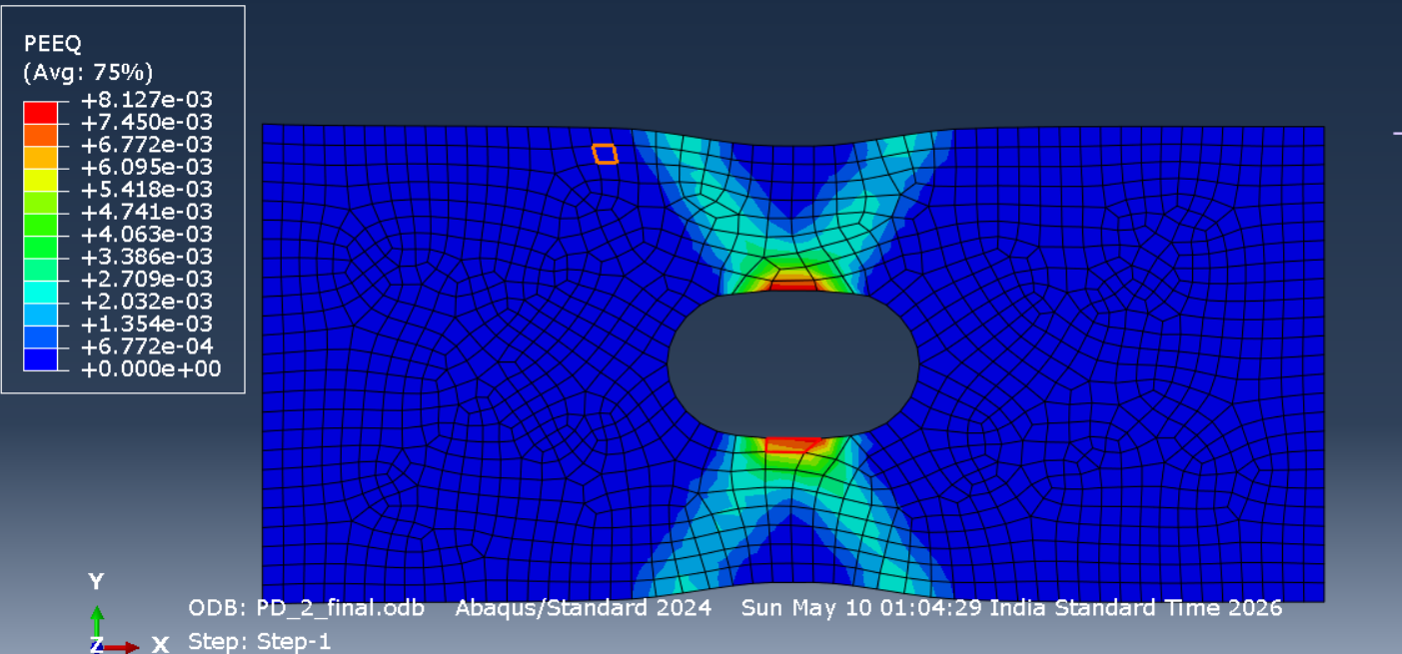
Figure 1

Fig. 1 give us how stress field develop in the plate in our model
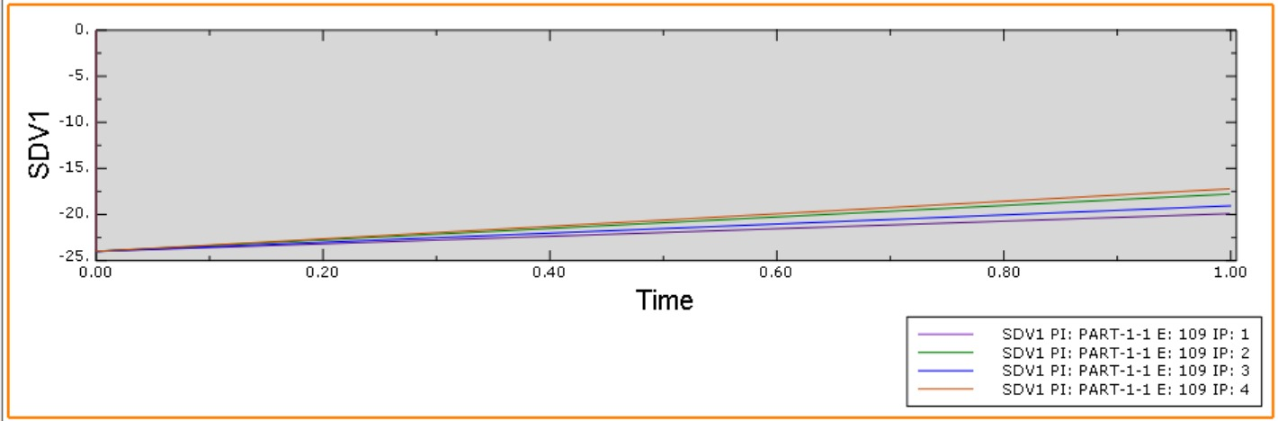
Figure 2

Fig. 2 give us how plastic strain developed in an element nodes in the plastic zone

6.3 Convergence Behaviour
The consistent tangent stiffness matrix improves greatly the convergence in the nonlinear analysis. The simulation demonstrates stable Newton-Raphson convergence throughout.

6.4 Comparison with Abaqus Built-in Model
- Yield stress values are nearly identical
- Plastic strain evolution is very similar
- Stable nonlinear convergence achieved
- UMAT requires slightly higher computational time
- Return mapping algorithm accurately maintains stress consistency

6.5 Discussion of Numerical Differences
Small numerical differences between UMAT and Abaqus built-in model may occur due to integration tolerance, iteration control, and numerical approximation during
stress correction. However, the overall constitutive behaviour remains very similar.
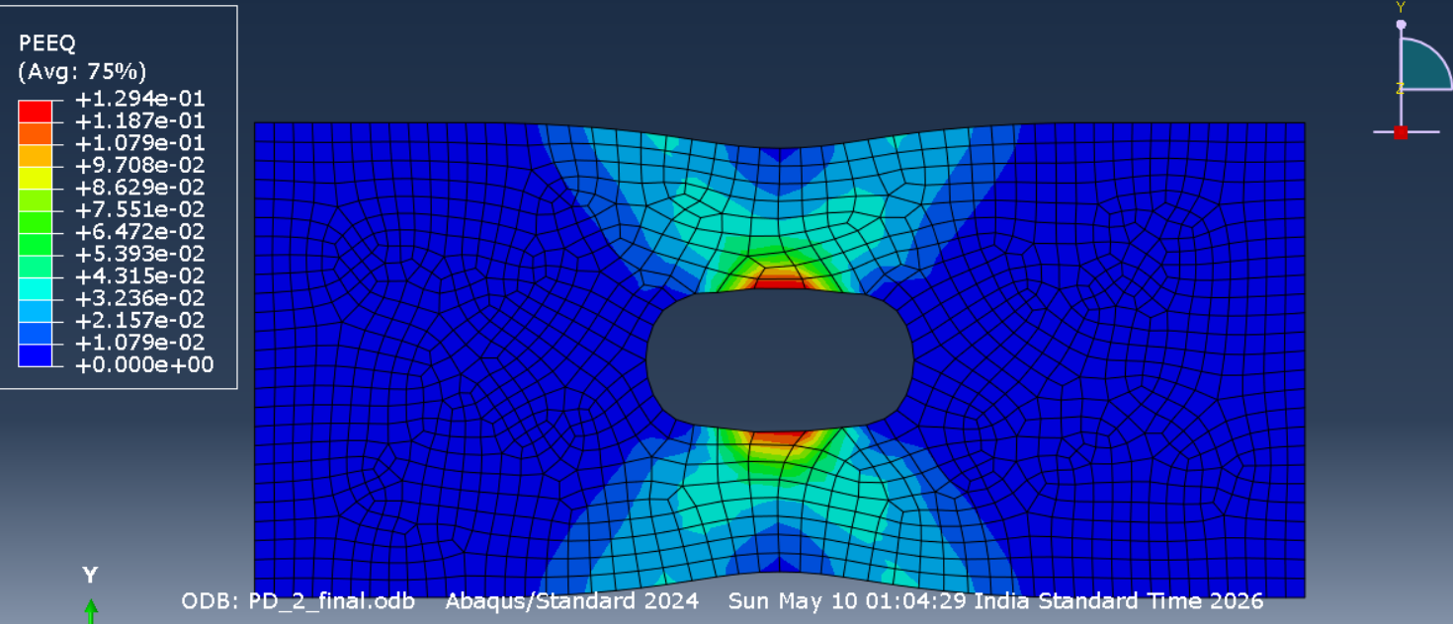
Figure 4
Figure 3

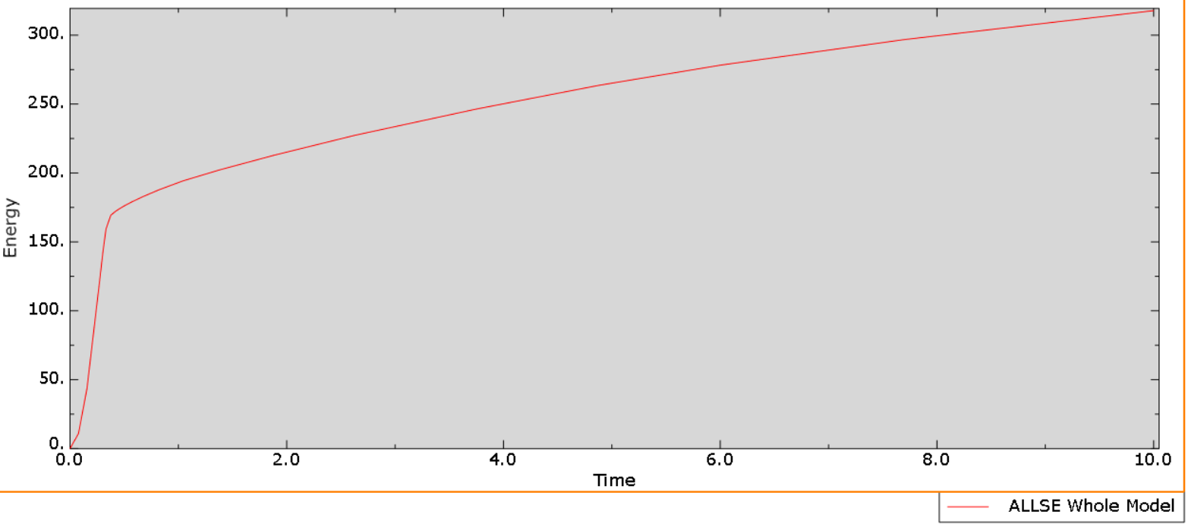
Figure 5

Here is the figure 3,4,5 for equivalent plastic strain at different time steps (Drucker–Prager plasticity model)

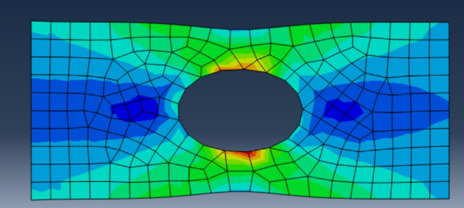

Figure 6

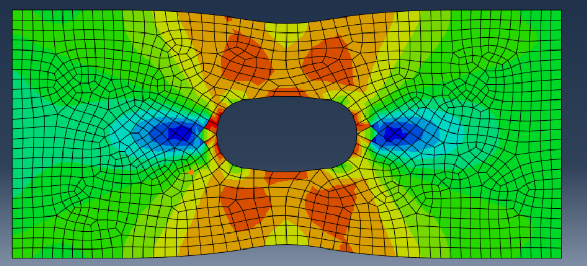
Figure 7
Fig. 7 gives us the stress state of built in Drucker–Prager plasticity model and Fig.6 is our UMAT subroutine model
There are some differences which is obvious due to mesh size and number of parameter included in built in and subroutine file and internal algorithm of work.

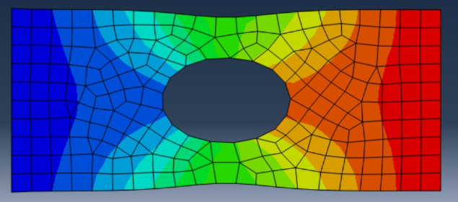

Figure 8
Fig 8 gives the displacement field of elements for our UMAT subroutine

CHAPTER 7 – CONCLUSIONS
A detailed computational plasticity framework for the Drucker–Prager constitutive model under plane stress condition was successfully developed using UMAT in Abaqus. The elastic predictor and plastic corrector algorithm was implemented systematically and validated using Abaqus built-in model.
- Pressure-dependent yielding behaviour successfully captured
- Elastic predictor and plastic corrector algorithm implemented successfully
- Return mapping algorithm maintained stress consistency
- Newton–Raphson iteration provided stable convergence
- UMAT results closely matched Abaqus built-in model
- The developed model is suitable for nonlinear finite element analysis

REFERENCES
[1] J. C. Simo and T. J. R. Hughes, Computational Inelasticity.
New York, NY, USA: Springer, 1998.
[2] Dassault Systèmes, Abaqus User Subroutine Reference Guide.
Providence, RI, USA: Dassault Systèmes Simulia Corp.
[3] D. C. Drucker and W. Prager, “Soil mechanics and plastic analysis or limit design,”
Quarterly of Applied Mathematics, vol. 10, no. 2, pp. 157–165, 1952.
[4] W. F. Chen, Plasticity in Reinforced Concrete.
New York, NY, USA: McGraw-Hill, 1982.
[5] T. Belytschko, W. K. Liu, B. Moran, and K. Elkhodary,
Nonlinear Finite Elements for Continua and Structures, 2nd ed.
Chichester, U.K.: Wiley, 2014.

